Araldite
Spectrum Report
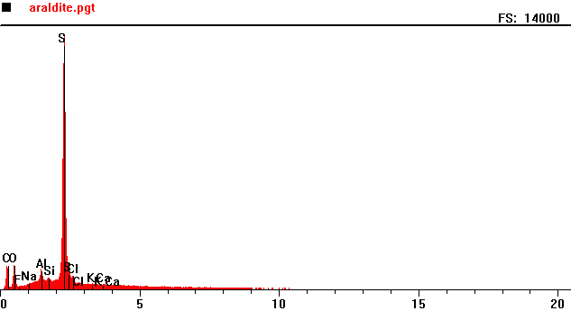
Counts per second
Full scale: 14000 cps
Energy KeV
Full scale: 14000 cps
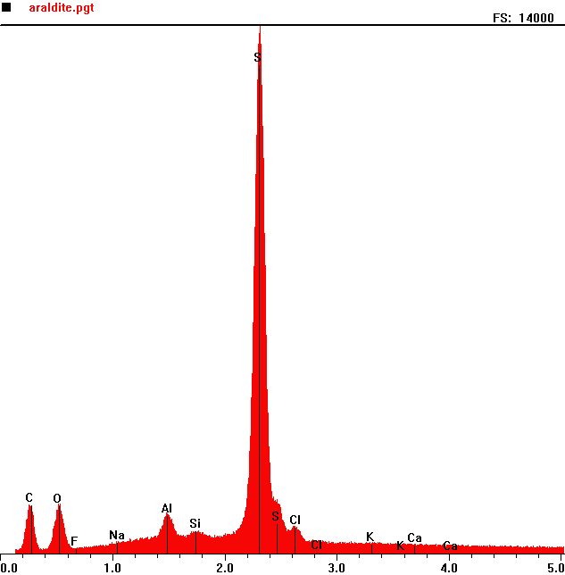
Counts per second
 | Element | Counts per second
C | Carbon | 1301
O | Oxygen | 1320
Al | Aluminum | 1151
S | Sulphur | 13961

Energy KeV
Araldite 2

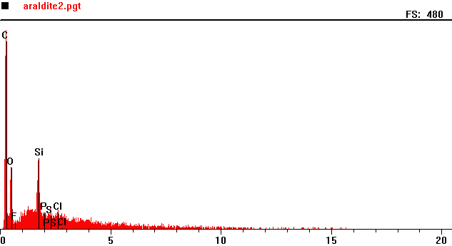
Counts per second
Full scale: 480 cps
Energy KeV
Full scale: 480 cps
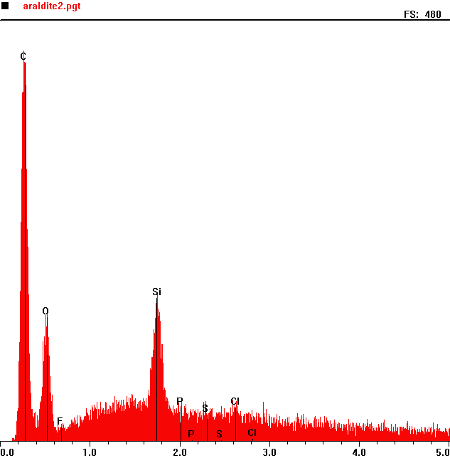
Counts per second
 | Element | Counts per second
C | Carbon | 445
O | Oxygen | 143
Si | Silicon | 164

Energy KeV

