EpoxiCure Room Temperature
Spectrum Report

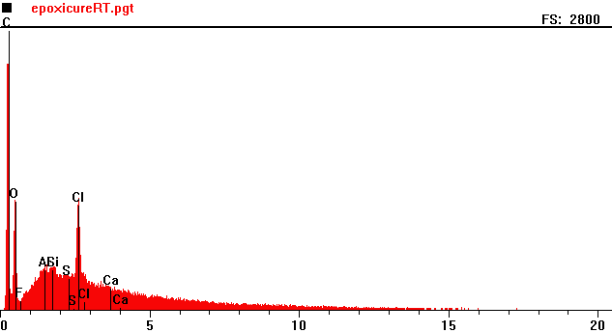
Counts per second
Full scale: 2800 cps
Energy KeV

Full scale: 2800 cps
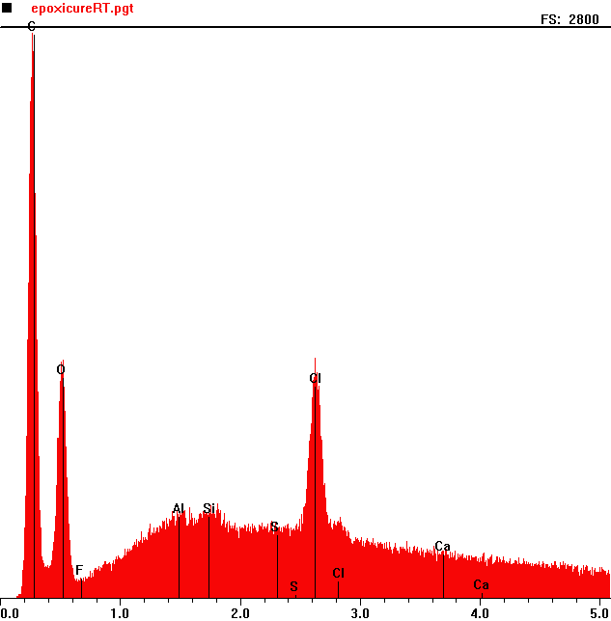
Counts per second
 | Element | Counts per second
C | Carbon | 2433
O | Oxygen | 1156
Cl | Chlorine | 1185

Energy KeV

