KonductoMet
Spectrum Report
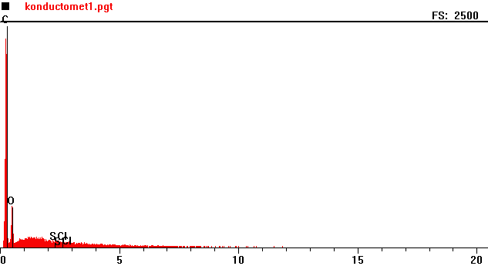
Counts per second
Full scale: 2500 cps
Energy KeV

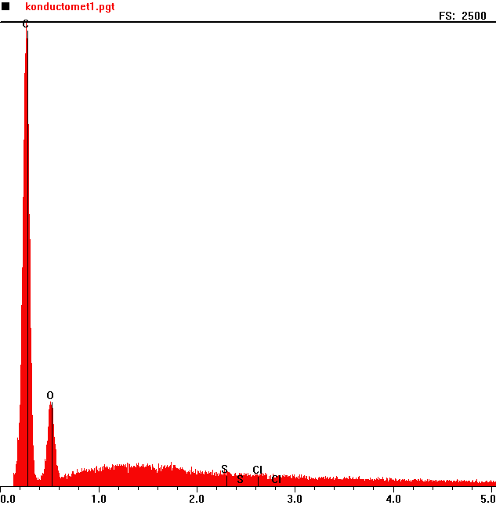
Counts per second
 | Element | Counts per second
C | Carbon | 2459
O | Oxygen | 455

Energy KeV
Full scale: 2500 cps
Konductomet 2
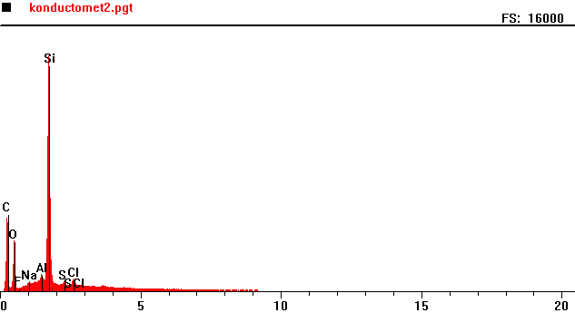
Counts per second
Full scale: 16000 cps
Energy KeV

Full scale: 16000 cps
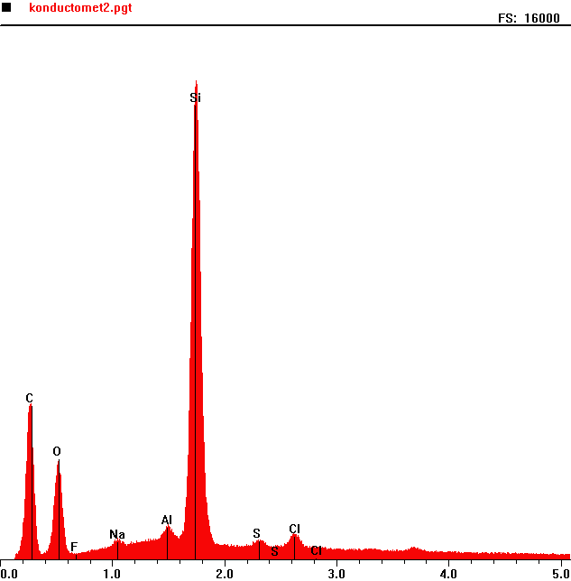
Counts per second
 | Element | Counts per second
C | Carbon | 4662
O | Oxygen | 2927
Al | Aluminum | 1074
Si | Silicon | 14236

Energy KeV

