ProbeMet
Spectrum Report
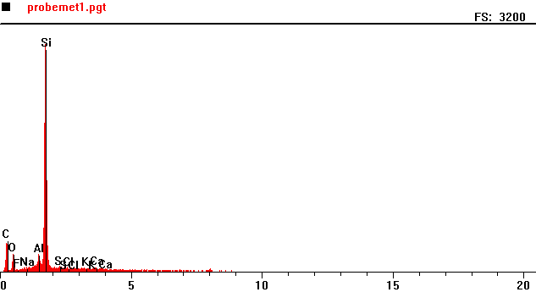
Counts per second
Full scale: 3200 cps
Energy KeV

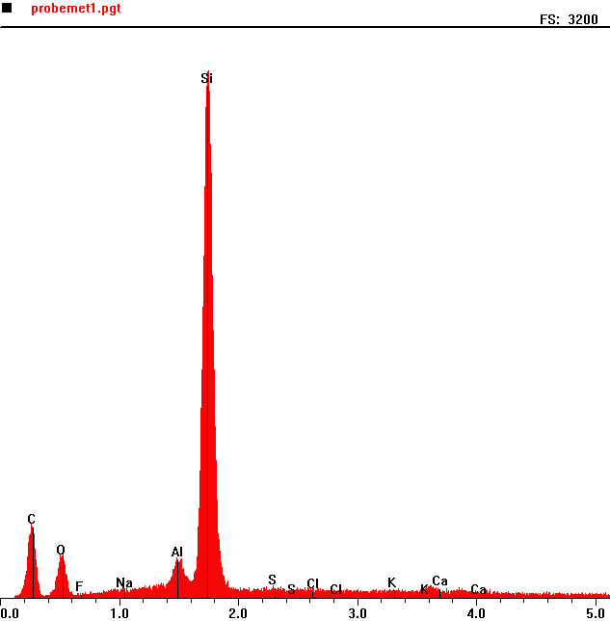
Counts per second
 | Element | Counts per second
C | Carbon | 420
O | Oxygen | 234
Al | Aluminium | 217
Si | Silica | 2928

Energy KeV
Full scale: 3200 cps
ProbeMet 2
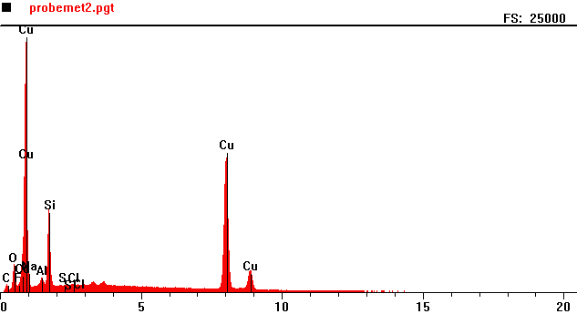
Counts per second
Full scale: 25000 cps
Energy KeV

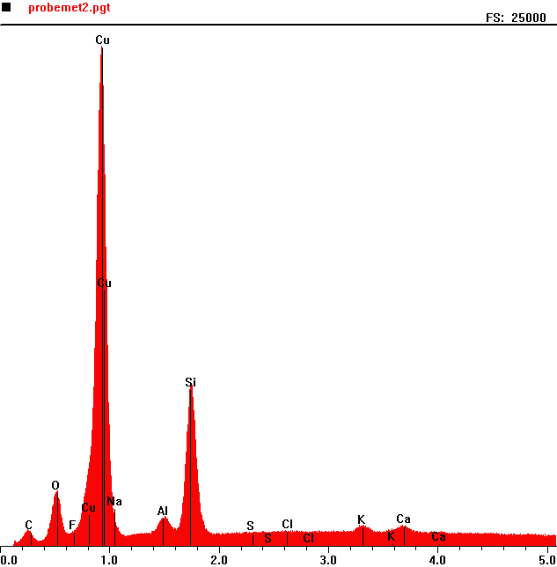
Counts per second
 | Element | Counts per second
C | Carbon | 762
O | Oxygen | 2631
Cu | Copper | 23938
Al | Aluminum | 1334
Si | Silicon | 7509

Full scale: 25000 cps
Energy KeV

