Spectrum Report – All resins

Araldite
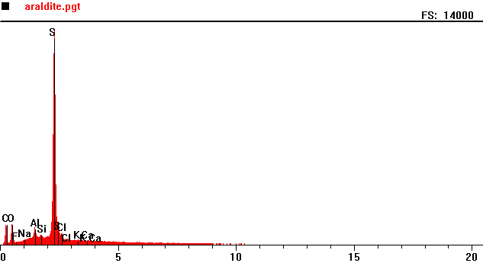
Counts per second
Full scale: 14000 cps
Energy KeV
Full scale: 14000 cps
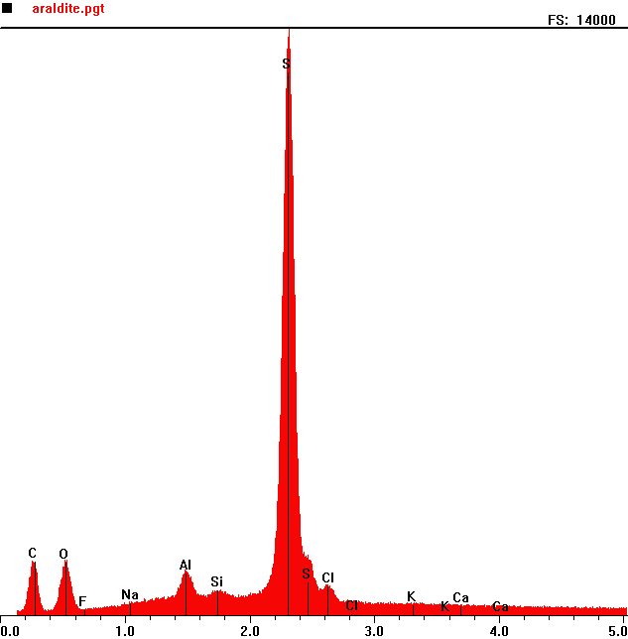
Counts per second
 | Element | Counts per second
C | Carbon | 1301
O | Oxygen | 1320
Al | Aluminum | 1151
S | Sulphur | 13961

Energy KeV
Araldite 2

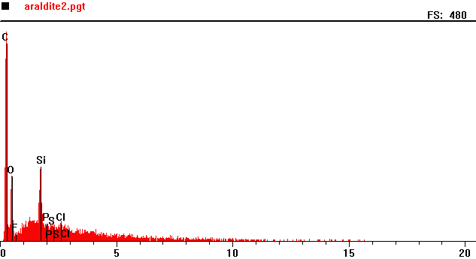
Counts per second
Full scale: 480 cps
Energy KeV
Full scale: 480 cps
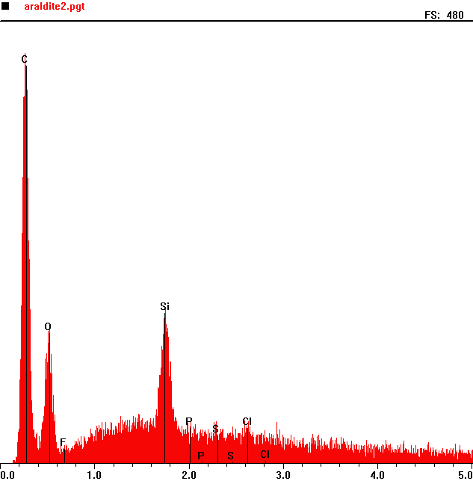
Counts per second
 | Element | Counts per second
C | Carbon | 445
O | Oxygen | 143
Si | Silicon | 164

Energy KeV
Araldite Slow

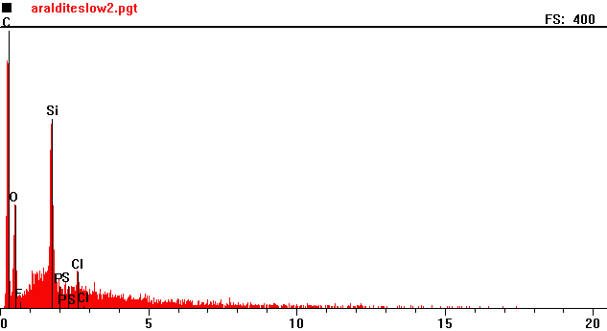
Counts per second
Full scale: 400 cps
Energy KeV
Full scale: 400 cps
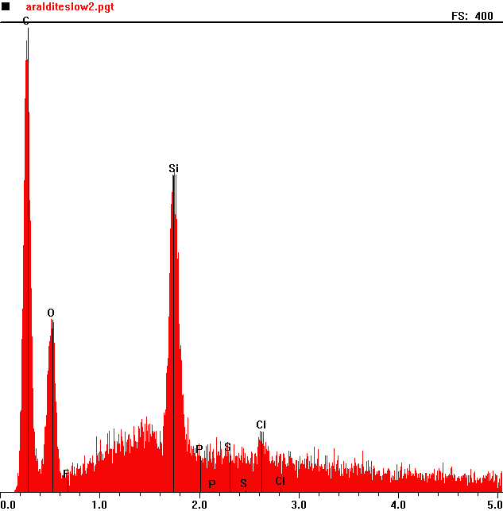
Counts per second
 | Element | Counts per second
C | Carbon | 396
O | Oxygen | 179
Si | Silicon | 281

Energy KeV
Ciba Geigy

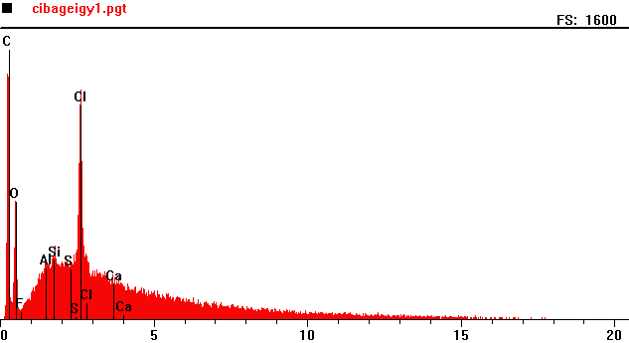
Counts per second
Full scale: 1600 cps
Energy KeV
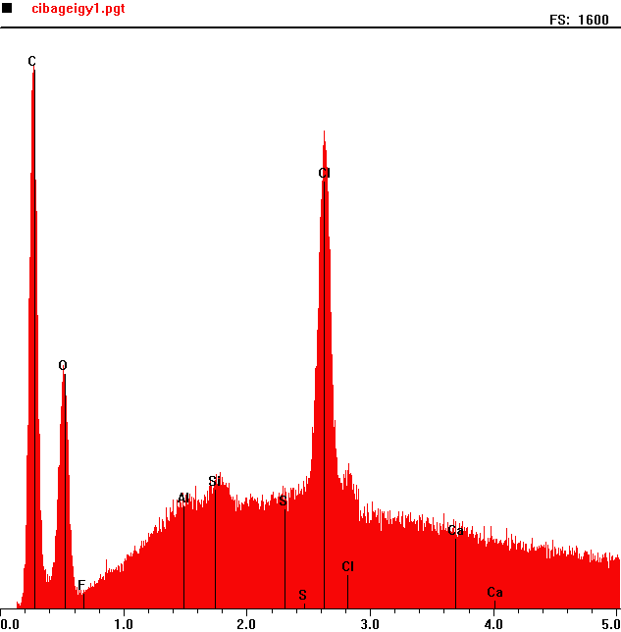
Counts per second
 | Element | Counts per second
C | Carbon | 1498
O | Oxygen | 672
Cl | Chlorine | 1315

Full scale: 1600 cps
Energy KeV
EpoFix

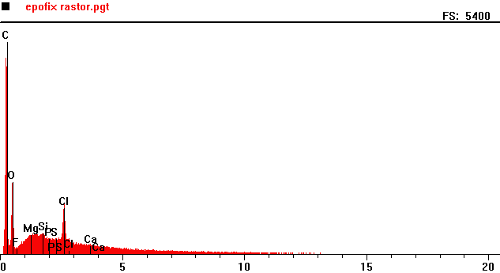
Counts per second
Full scale: 5400 cps
Energy KeV
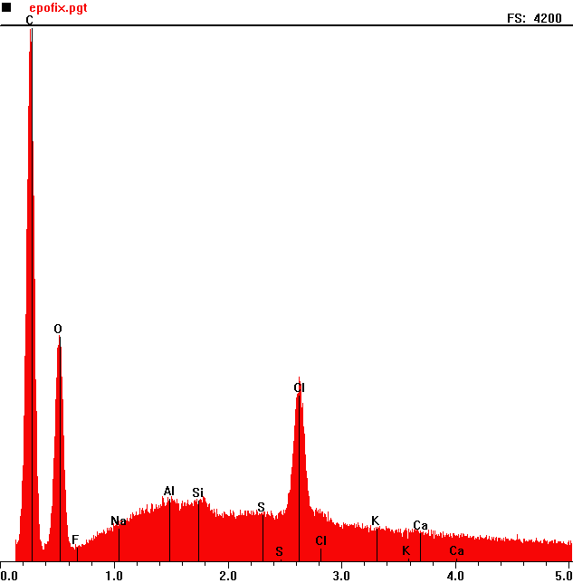
Counts per second
 | Element | Counts per second
C | Carbon | 4185
O | Oxygen | 1772
Cl | Chlorine | 1407

Full scale: 5400 cps
Energy KeV
EpoHeat

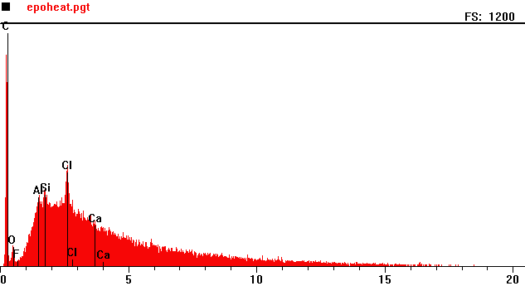
Counts per second
Full scale: 1200 cps
Energy KeV

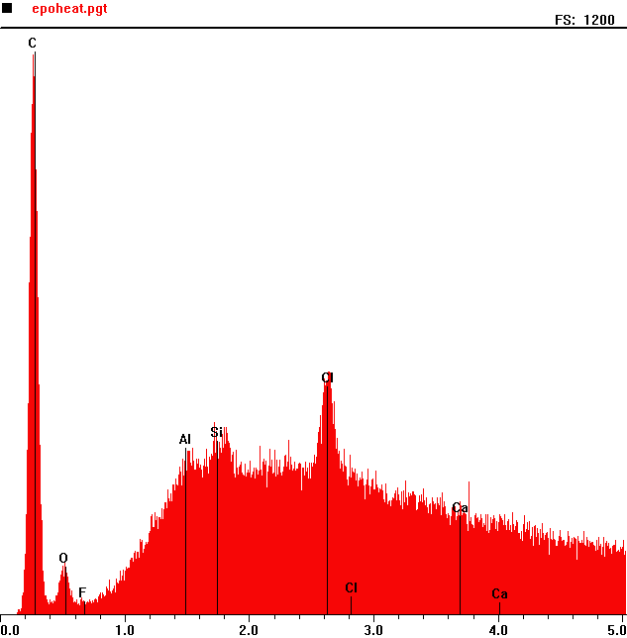
Counts per second
 | Element | Counts per second
C | Carbon | 1154
O | Oxygen | 108
Cl | Chlorine | 559

Full scale: 1200 cps
Energy KeV
EpoThin

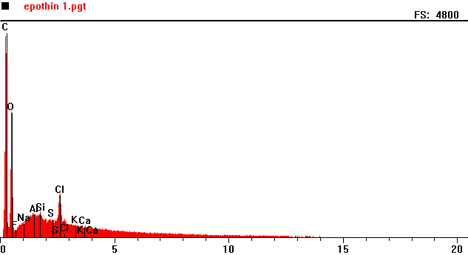
Counts per second
Full scale: 4800 cps
Energy KeV

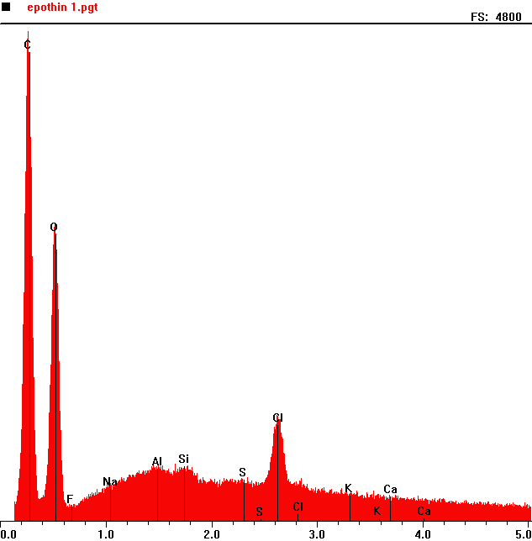
Counts per second
 | Element | Counts per second
C | Carbon | 4722
O | Oxygen | 2865
Cl | Chlorine | 1039

Full scale: 4800 cps
Energy KeV
Epoxicure - 65°C Cure

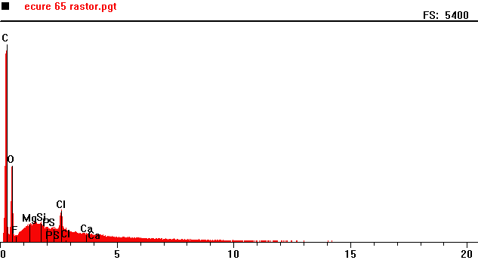
Counts per second
Energy KeV
Full scale: 5400 cps
Full scale: 5400 cps
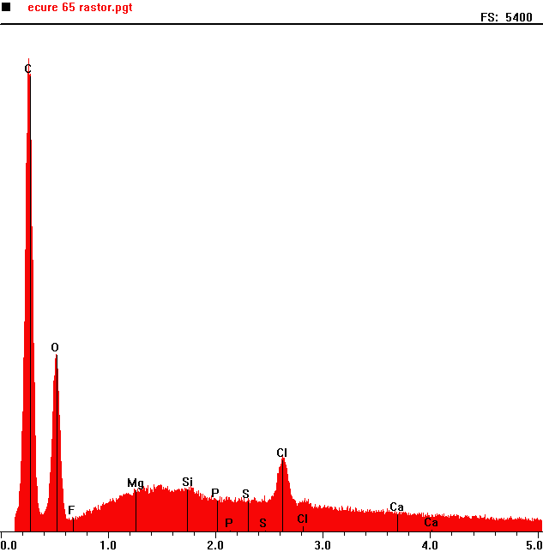
Counts per second
 | Element | Counts per second
C | Carbon | 5027
O | Oxygen | 1888
Cl | Chlorine | 820

Energy KeV
EpoxiCure - Room Temperature Cure

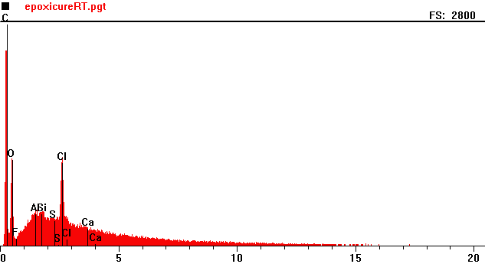
Counts per second
Full scale: 2800 cps
Energy KeV

Full scale: 2800 cps
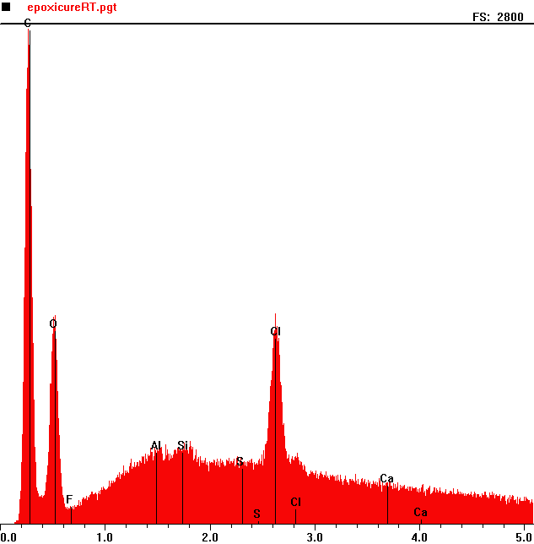
Counts per second
 | Element | Counts per second
C | Carbon | 2433
O | Oxygen | 1156
Cl | Chlorine | 1185

Energy KeV
KonductoMet
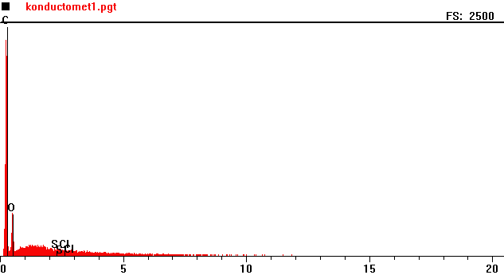
Counts per second
Full scale: 2500 cps
Energy KeV

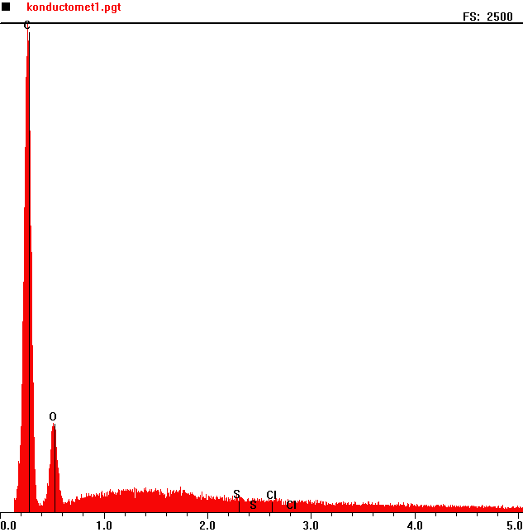
Counts per second
 | Element | Counts per second
C | Carbon | 2459
O | Oxygen | 455

Energy KeV
Full scale: 2500 cps
Konductomet 2
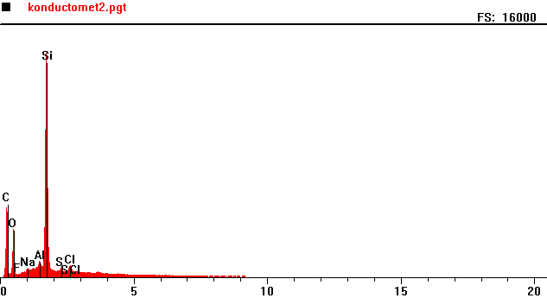
Counts per second
Full scale: 16000 cps
Energy KeV

Full scale: 16000 cps
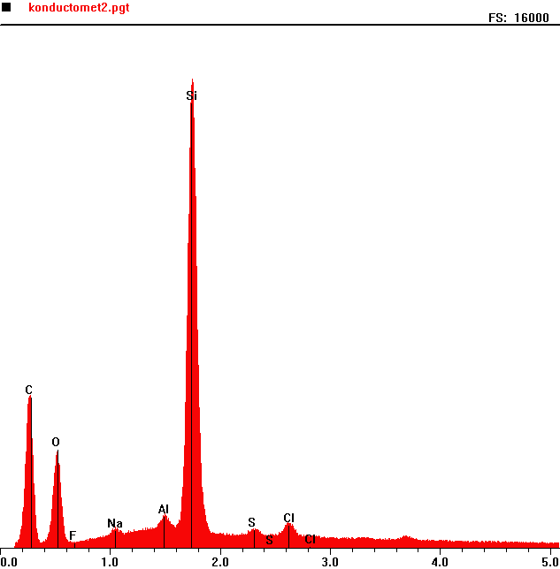
Counts per second
 | Element | Counts per second
C | Carbon | 4662
O | Oxygen | 2927
Al | Aluminum | 1074
Si | Silicon | 14236

Energy KeV
Korapox 439

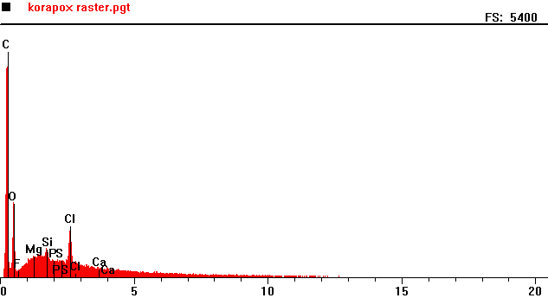
Counts per second
Energy KeV
Full scale: 5400 cps

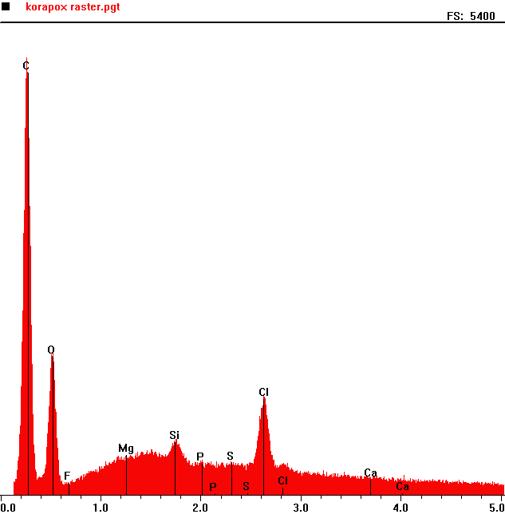
Counts per second
Full scale: 5400 cps
 | Element | Counts per second
C | Carbon | 4882
O | Oxygen | 1584
Si | Silica | 613
Cl | Chlorine | 1106

Energy KeV
Petropoxy

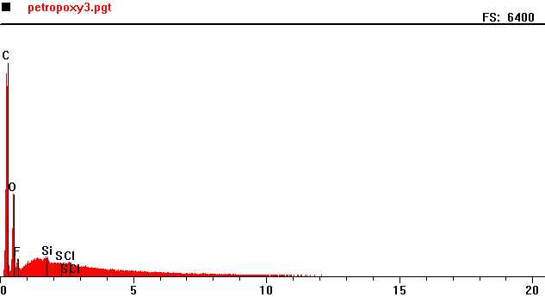
Counts per second
Full scale: 6400 cps
Energy KeV
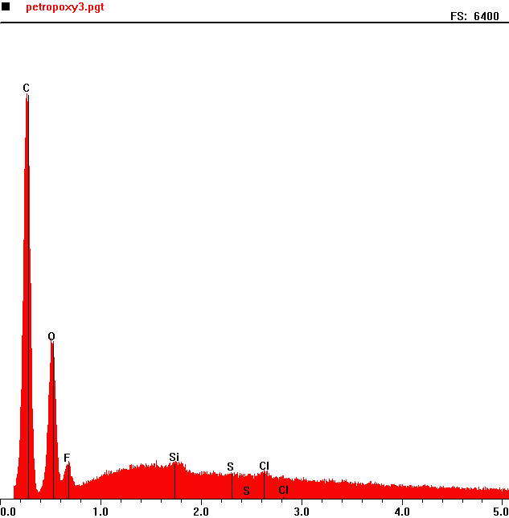
Counts per second
 | Element | Counts per second
C | Carbon | 5443
O | Oxygen | 2079
F | Fluorine | 502
Si | Silica | 498
Cl | Chlorine | 351

Full scale: 6400 cps
Energy KeV
ProbeMet

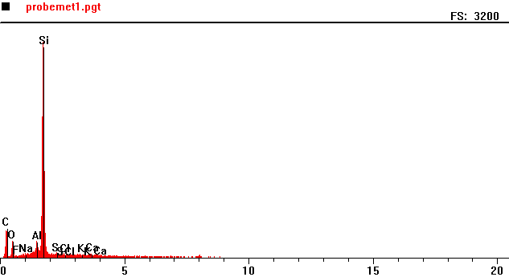
Counts per second
Full scale: 3200 cps
Energy KeV

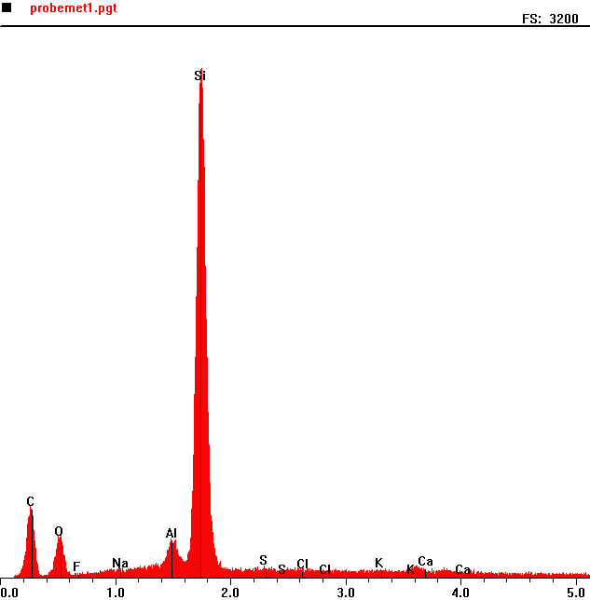
Counts per second
 | Element | Counts per second
C | Carbon | 420
O | Oxygen | 234
Al | Aluminium | 217
Si | Silica | 2928

Energy KeV
Full scale: 3200 cps
ProbeMet 2
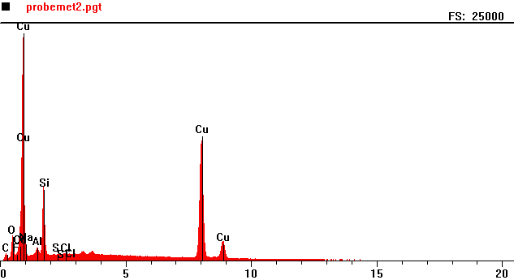
Counts per second
Full scale: 25000 cps
Energy KeV

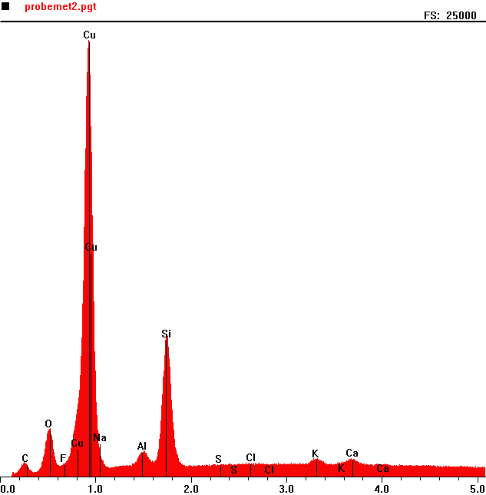
Counts per second
 | Element | Counts per second
C | Carbon | 762
O | Oxygen | 2631
Cu | Copper | 23938
Al | Aluminum | 1334
Si | Silicon | 7509

Full scale: 25000 cps
Energy KeV
Robnor Resin

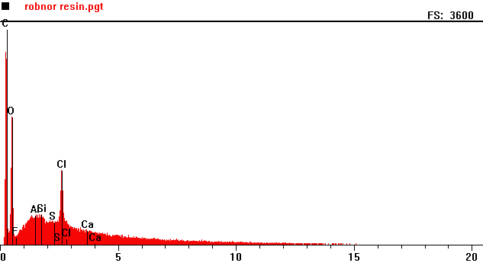
Counts per second
Full scale: 3600 cps
Energy KeV

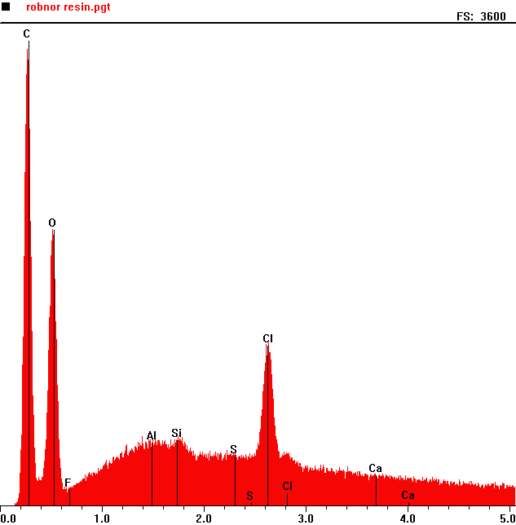
Counts per second
 | Element | Counts per second
C | Carbon | 3473
O | Oxygen | 12060
Si | Silica | 513
Cl | Chlorine | 1149

Full scale: 3600 cps
Energy KeV

Specifix
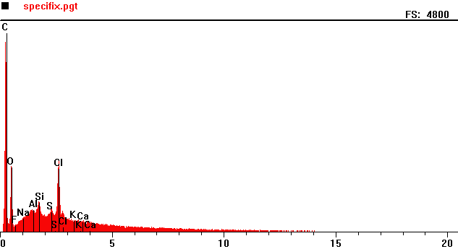
Counts per second
Full scale: 4200 cps
Energy KeV
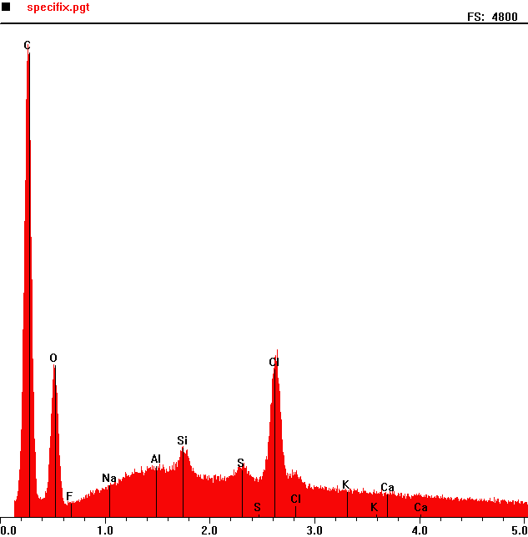
Counts per second
 | Element | Counts per second
C | Carbon | 4526
O | Oxygen | 1480
Si | Silicon | 688
s | Sulphur | 481
Cl | Chlorine | 1530

Energy KeV
Full scale: 4200 cps
Transoptic

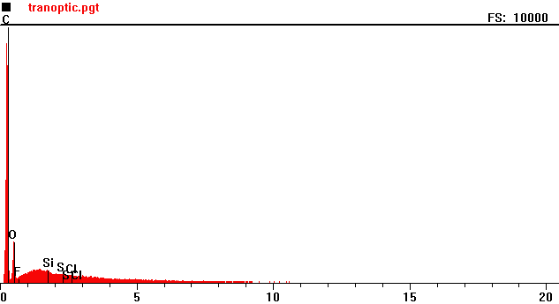
Counts per second
Full scale: 10000 cps
Energy KeV
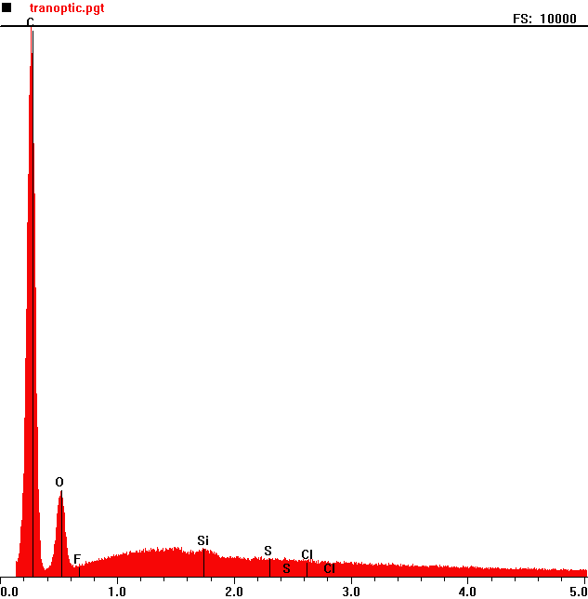
Counts per second
 | Element | Counts per second
C | Carbon | 9925
O | Oxygen | 1549
Si | Silicon | 500

Full scale: 10000 cps
Energy KeV
TransOptic 2
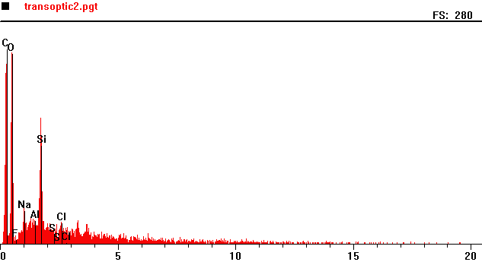
Counts per second
Full scale: 280 cps
Energy KeV
Full scale: 280 cps
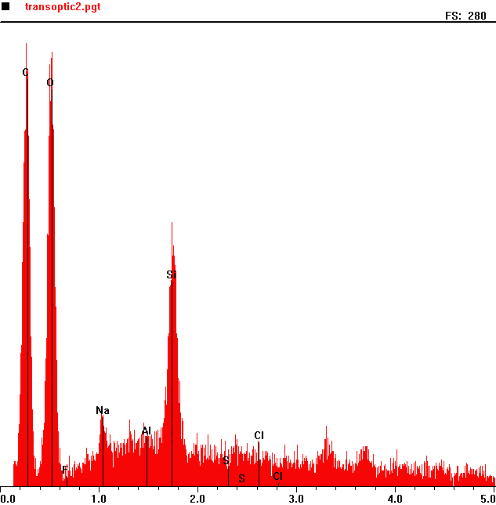
Counts per second
 | Element | Counts per second
C | Carbon | 279
O | Oxygen | 258
Na | Sodium | 43
Cl | Chlorine | 168

Energy KeV
Varian
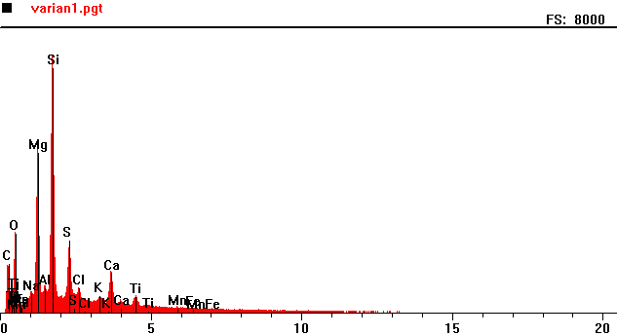
Counts per second
Full scale: 8000 cps
Energy KeV
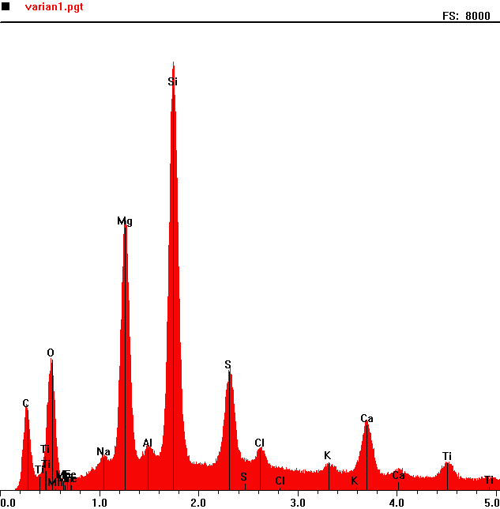
Counts per second
 | Element | Counts per second
C | Carbon | 1428
O | Oxygen | 2244
Mg | Magnesium | 4632
Si | Silicon | 7322
S | Sulphur | 2042

Full scale: 8000 cps
Energy KeV

Varian 2
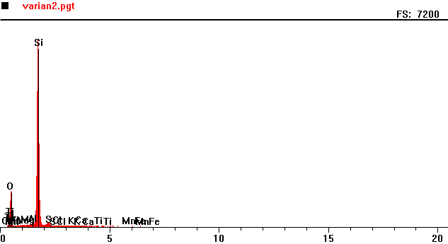
Counts per second
Full scale: 7200 cps
Energy KeV

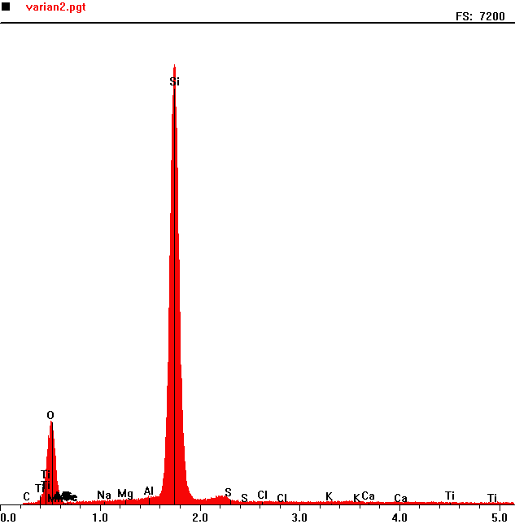
Counts per second
 | Element | Counts per second
O | Oxygen | 1248
Si | Silicon | 6574

Full scale: 7200 cps
Energy KeV

