Varian
Spectrum Report
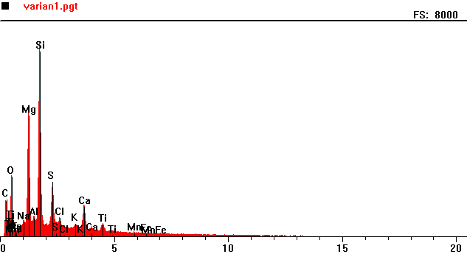
Counts per second
Full scale: 8000 cps
Energy KeV
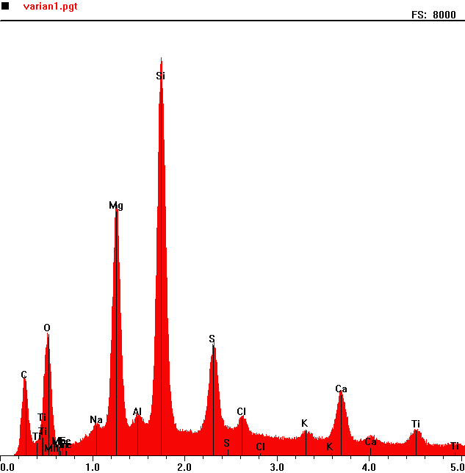
Counts per second
 | Element | Counts per second
C | Carbon | 1428
O | Oxygen | 2244
Mg | Magnesium | 4632
Si | Silicon | 7322
S | Sulphur | 2042

Full scale: 8000 cps
Energy KeV

Varian 2
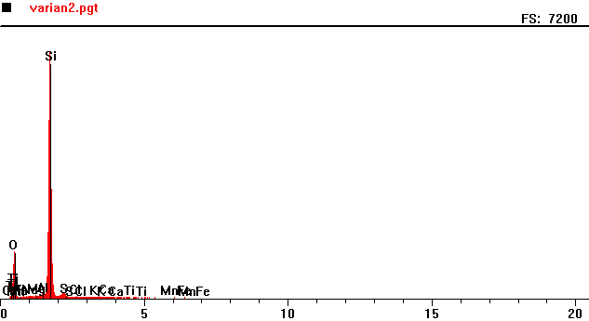
Counts per second
Full scale: 7200 cps
Energy KeV

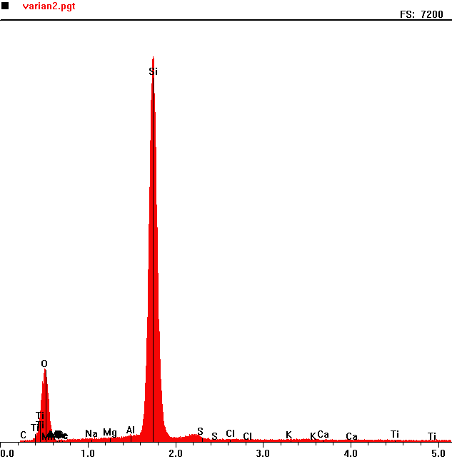
Counts per second
 | Element | Counts per second
O | Oxygen | 1248
Si | Silicon | 6574

Full scale: 7200 cps
Energy KeV

