Epoxicure 65
Spectrum Report

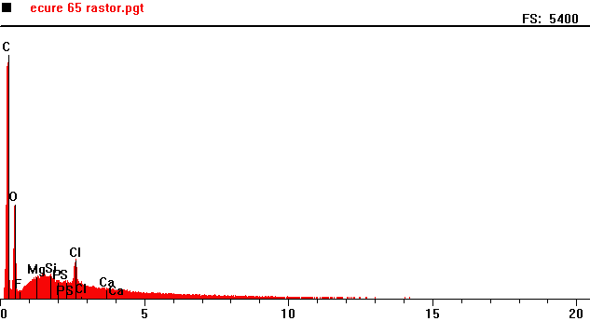
Counts per second
Energy KeV
Full scale: 5400 cps
Full scale: 5400 cps
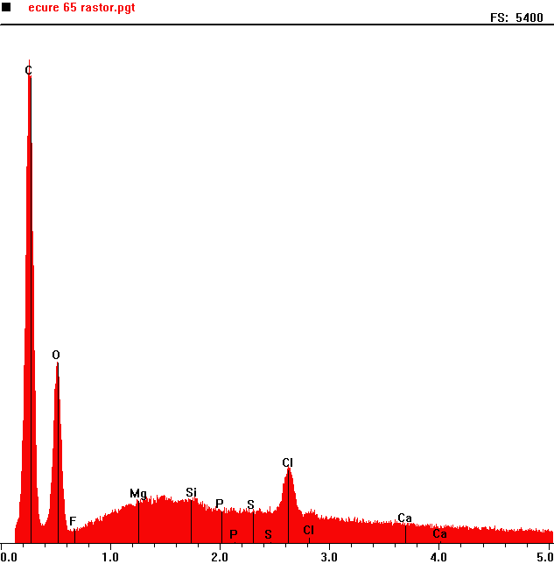
Counts per second
 | Element | Counts per second
C | Carbon | 5027
O | Oxygen | 1888
Cl | Chlorine | 820

Energy KeV

