Tencor Alpha-Step Profile - Konductomet

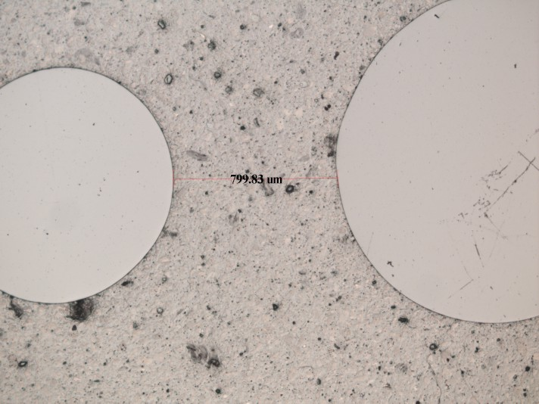

Maximum Depth = 3.4um

