Tencor Alpha-Step Profile - ProbeMet

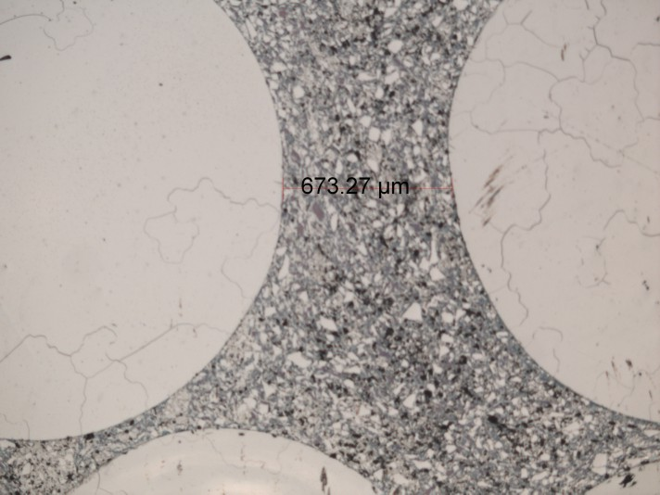

Maximum Depth = 1.7um

