Tencor Alpha-Step Profile - Robnor Resin

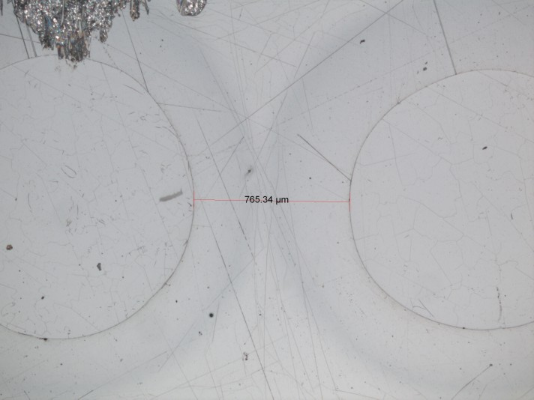

Maximum Depth = 3.0um

